

|  |
| --- |
| *BS Cyber Security Department AU* |

|  |  |
| --- | --- |
| **Registration ID** | **233026** |
| **Submitted By** | **Muhammad Sohaib Rafiq** |
| **Submitted To** | **Mam Fazia Nasir** |
| **Date of Submission** | **04/24/2025** |
| **Lab NO.** | **AppFlask** |
| **Subject** | **SSDD LAB** |

**Pre requisites:**

Java should be installed on your machine.

If java isn’t installed, click on this link:

https://www.oracle.com/java/technologies/downloads/#jdk21-

windows

and install it.

**Downloads the Jenkins:**

**The official website for Jenkins is Jenkins. If you click the given link,**

**you can get the home page of the Jenkins official website as shown**

**below.**

**Click on download and download Jenkins General war package:**

**Starting Jenkins**

**Open the command prompt. From the command prompt, browse to**

**the directory where the jenkins.war file is present. Run the following**

**command**

**D:\&gt;Java –jar Jenkins.war**

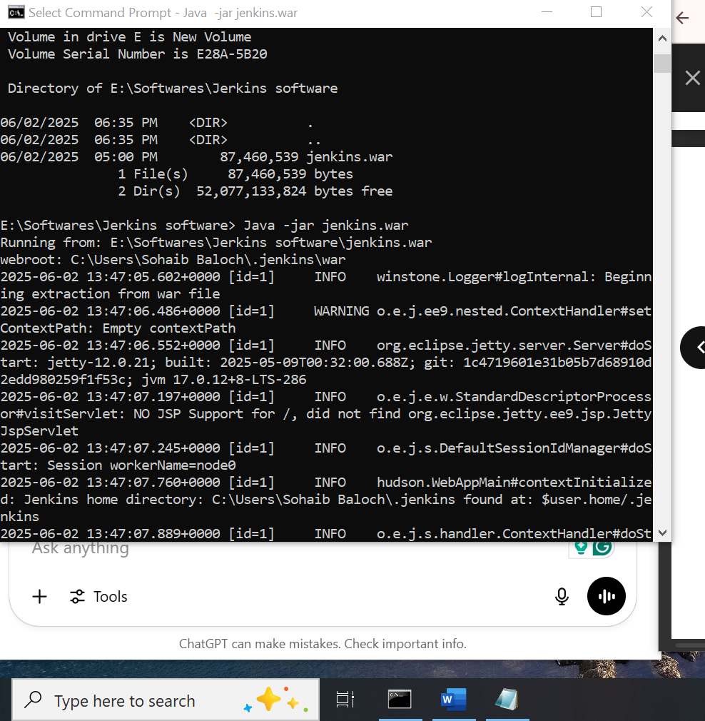

**Accessing Jenkins:**

**3. Once Jenkins is up and running, one can access Jenkins from the link**

− <http://localhost:8080>

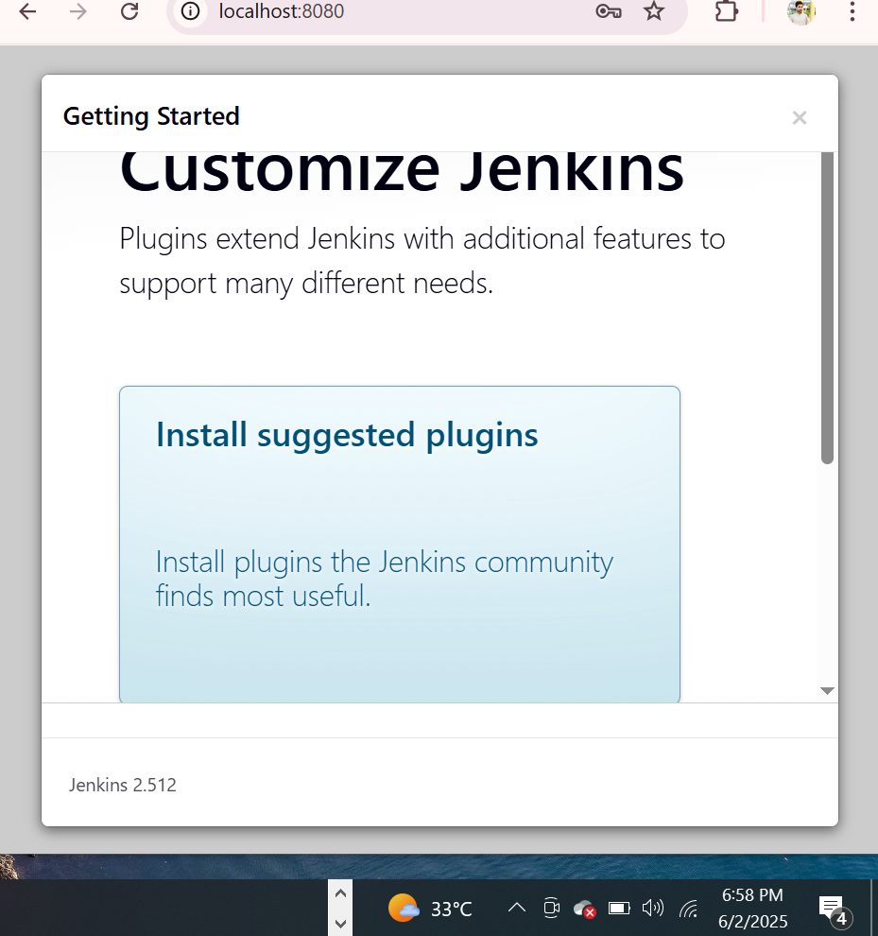

**Now the jerkins are running on the tomcat a apache :**

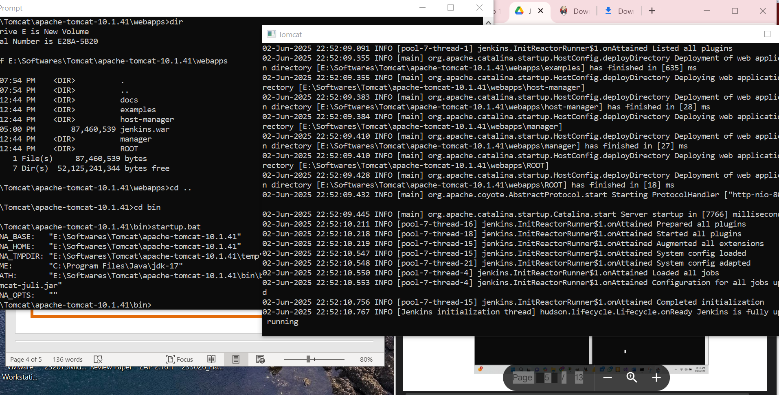

**4. Open the browser and go to the link − http://localhost:8080/jenkins. Jenkins will be up**

**and running on tomcat.**

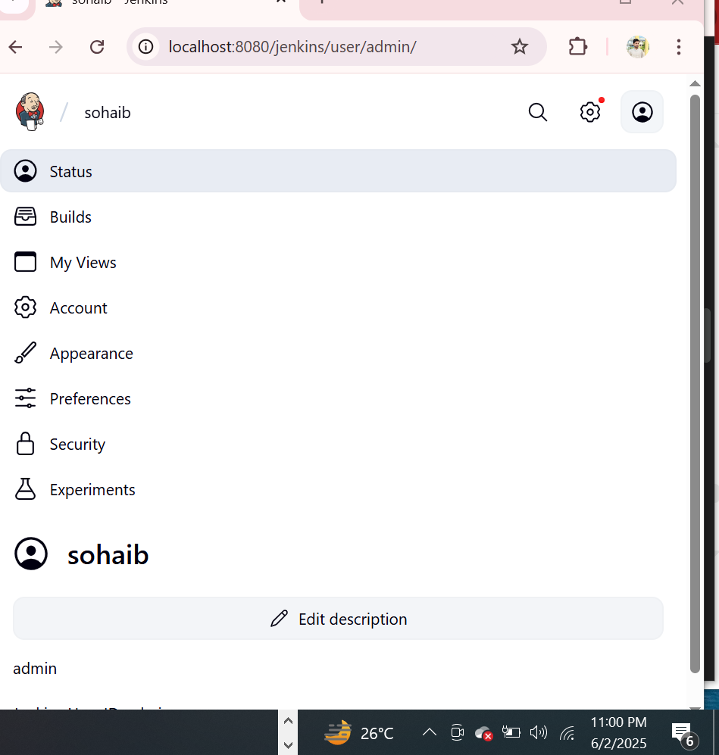

**Jenkins - Git Setup**

**1. In your Jenkins Dashboard (Home screen), click the Manage**

**Jenkins option on the lefthand side.**

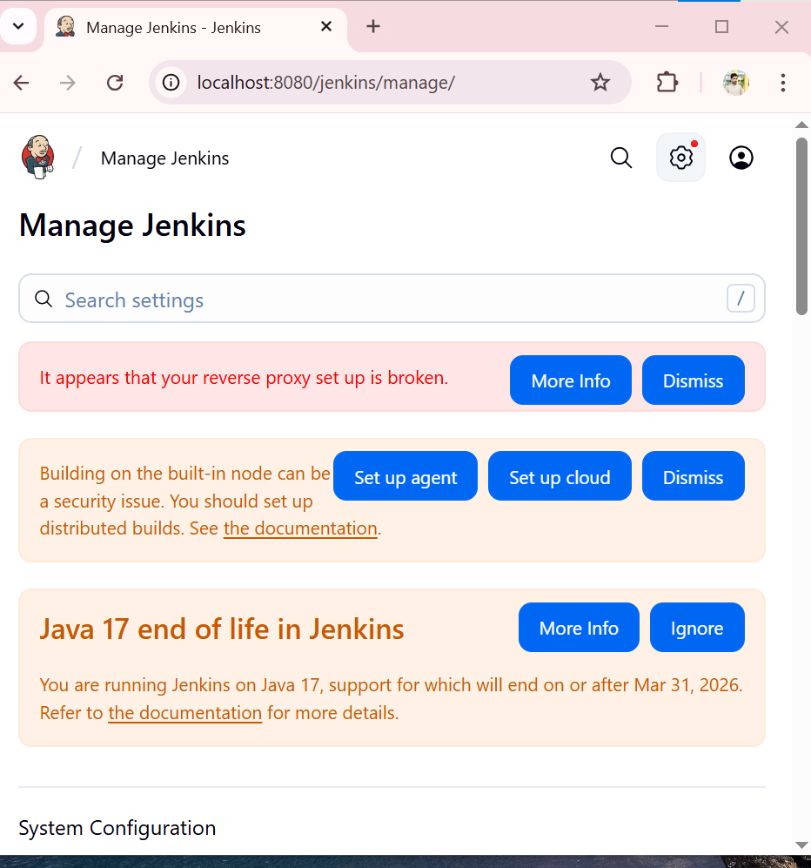

**2. In the next screen, click the ‘Plugins’ option. click the Available**

**tab. This tab will give a list of plugins which are available for**

**downloading. In the ‘Filter’ tab type ‘Git Push’**

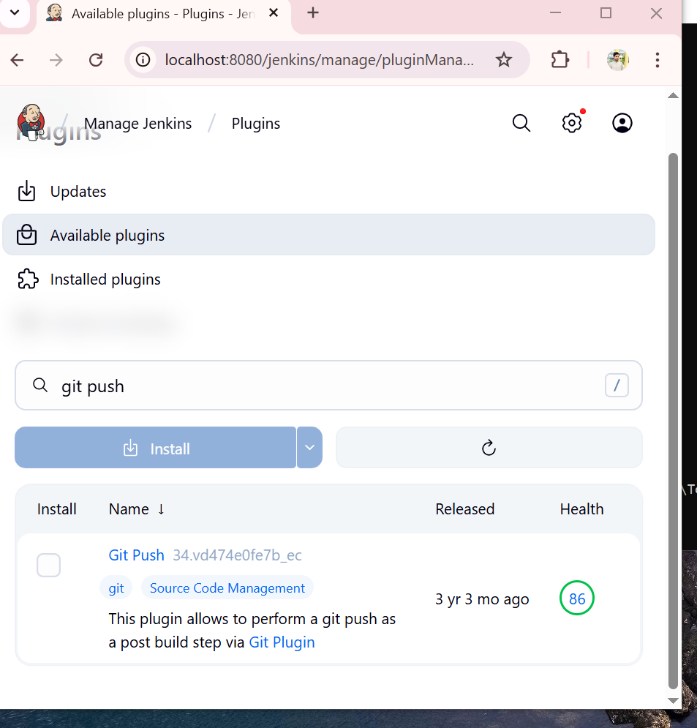

**7. If you click on git, you will have to fill in the details of your gut**

**repository and your credentials.**

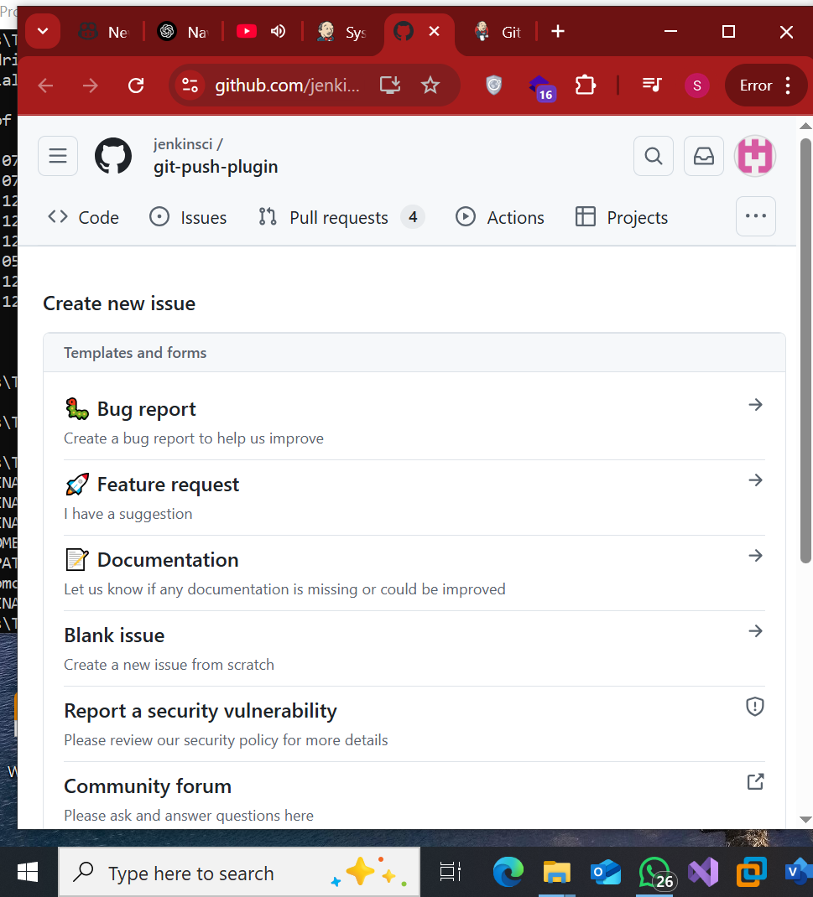

**Jenkins – Configuration**

**1. You one can get the various configuration options for Jenkins**

**by clicking the ‘Manage Jenkins’ option from the left hand**

**menu side.**

**2. Click on System. Discussed below are some of the Jenkins**

**configuration settings which can be carried out.**

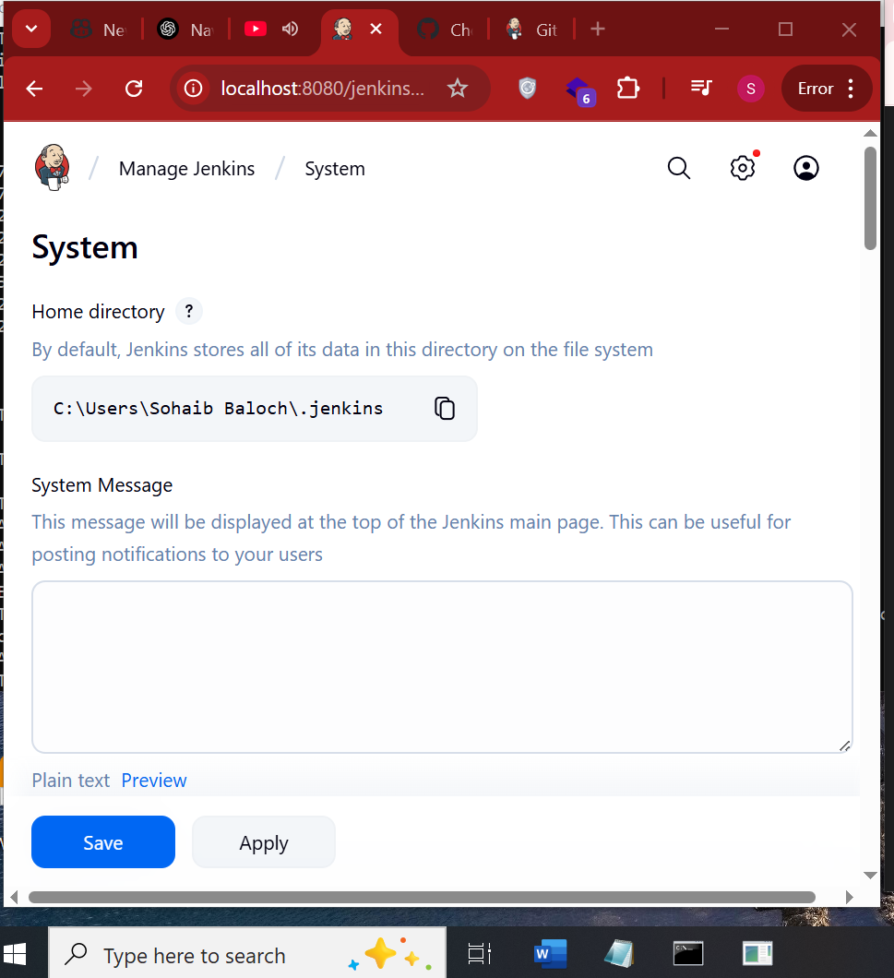

**3. Open Environment Variables:**

**• In the System Properties window, click the &quot;Environment Variables...&quot; button.**

**4. Add JENKINS_HOME Variable:**

**• In the Environment Variables window, you will see two sections: one for User**

**variables and one for System variables.**

**• If you want to set JENKINS_HOME for a specific user, add it to the User variables.**

**If you want to set it system-wide, add it to the System variables.**

**• Click the &quot;New...&quot; button in the appropriate section.**

**• Set the Variable name to JENKINS_HOME.**

**• Set the Variable value to the base directory location where you want to store**

**Jenkins data.**

**5. Click OK:**

**• Click &quot;OK&quot; to close the Environment Variables window.**

**• Click &quot;OK&quot; again to close the System Properties window.**

**6. Restart Any Open Command Prompts or Jenkins Services:**

**• If you have any open Command Prompt windows or services that rely on Jenkins,**

**restart them to ensure they recognize the new environment variable.**

**Now, JENKINS_HOME should be set as an environment variable on your Windows system. Note**

**that any new processes will pick up this variable, but existing processes may not unless they are**

**restarted.**

**To restart Jenkins, in cmd navigate to the directory having war file:**

**java -jar jenkins.war**

**2.2. # of executors**

**This refers to the total number of concurrent job executions that can take place on the Jenkins**

**machine. This can be changed based on requirements. Sometimes the recommendation is to**

**keep this number the same as the number of CPU on the machines for better performance.**

**2.3. Environment Variables**

**This is used to add custom environment variables which will apply to all the jobs. These are key-**

**value pairs and can be accessed and used in Builds wherever required.**

**2.4. Jenkins URL**

**By default, the Jenkins URL points to localhost. If you have a domain name setup for your**

**machine, set this to the domain name else overwrite localhost with IP of machine.**

**2.5. Email Notification**

**In the email Notification area, you can configure the SMTP settings for sending out emails. This**

**is required for Jenkins to connect to the SMTP mail server and send out emails to the recipient**

**list.**

**Setting up the:**

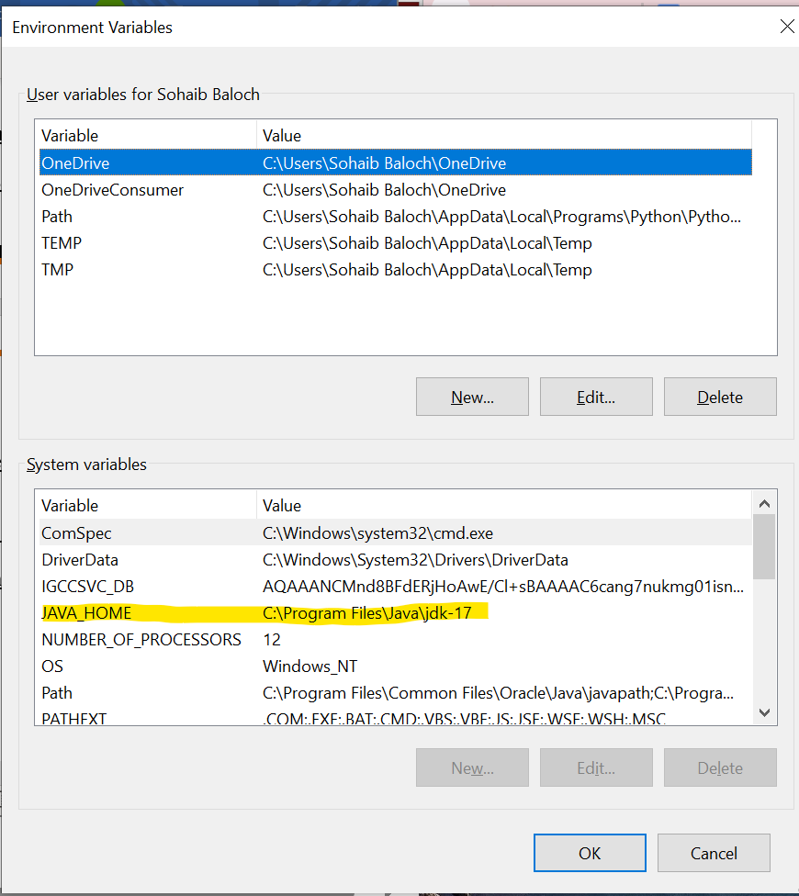

**JAVA Hello world file:**

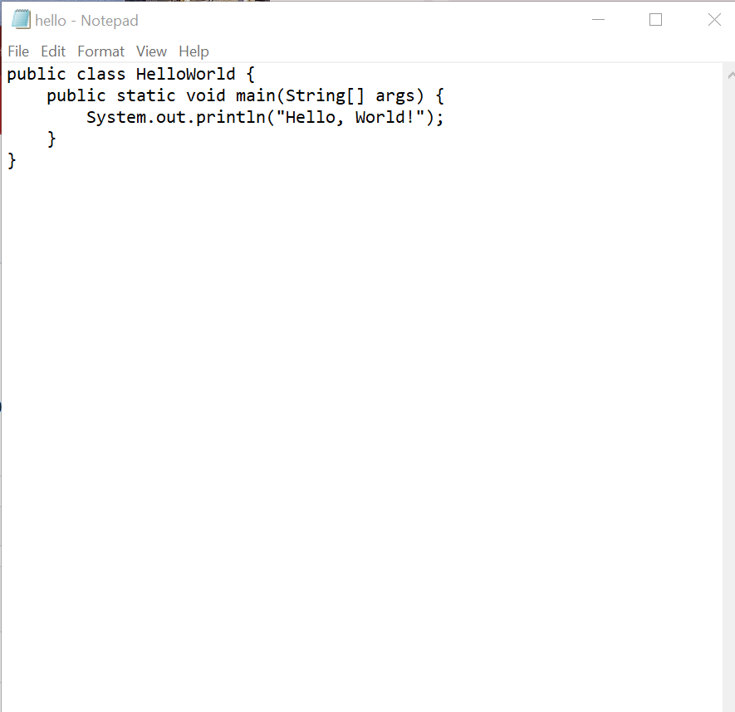

**Step 3 − The following screen will come up in which you can specify**

**the details of the job.**

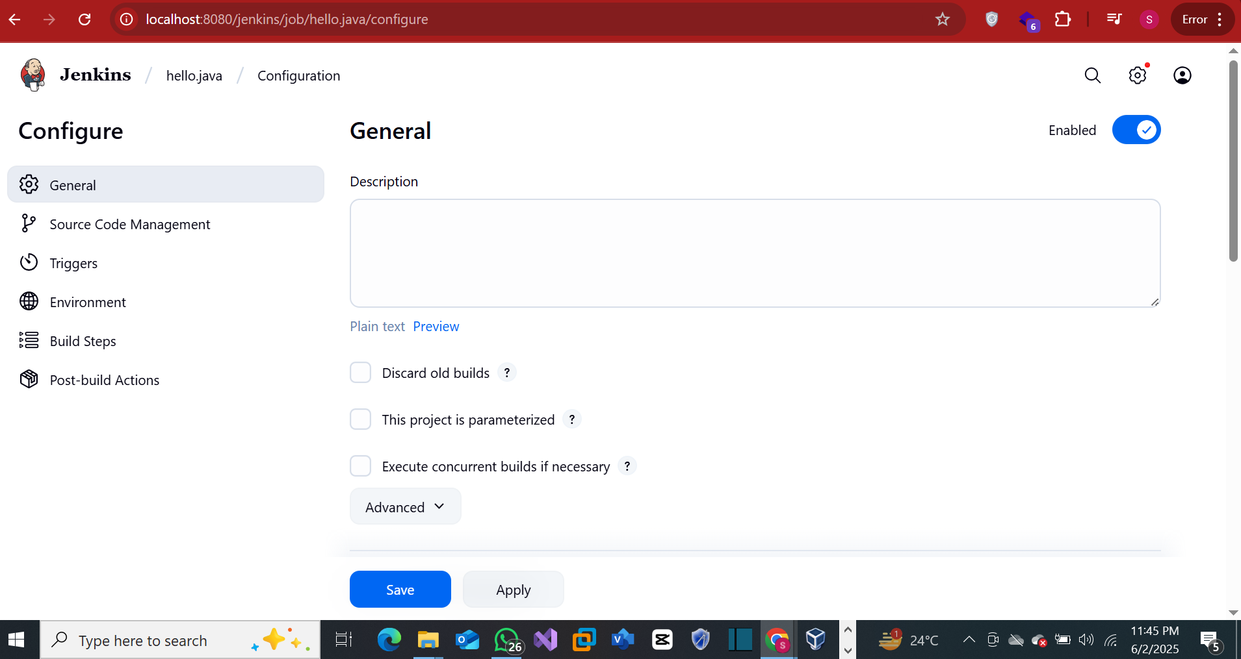

**Step 4 − We need to specify the location of files which need to be**

**built. If you repository if hosted on Github, you can also enter the**

**url of that repository here:**

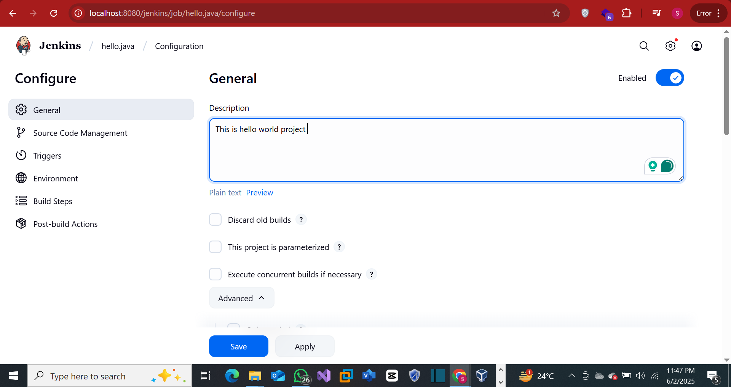

**Step 5 − Now go to the Build section and click on Add build step →**

**Execute Windows batch command**

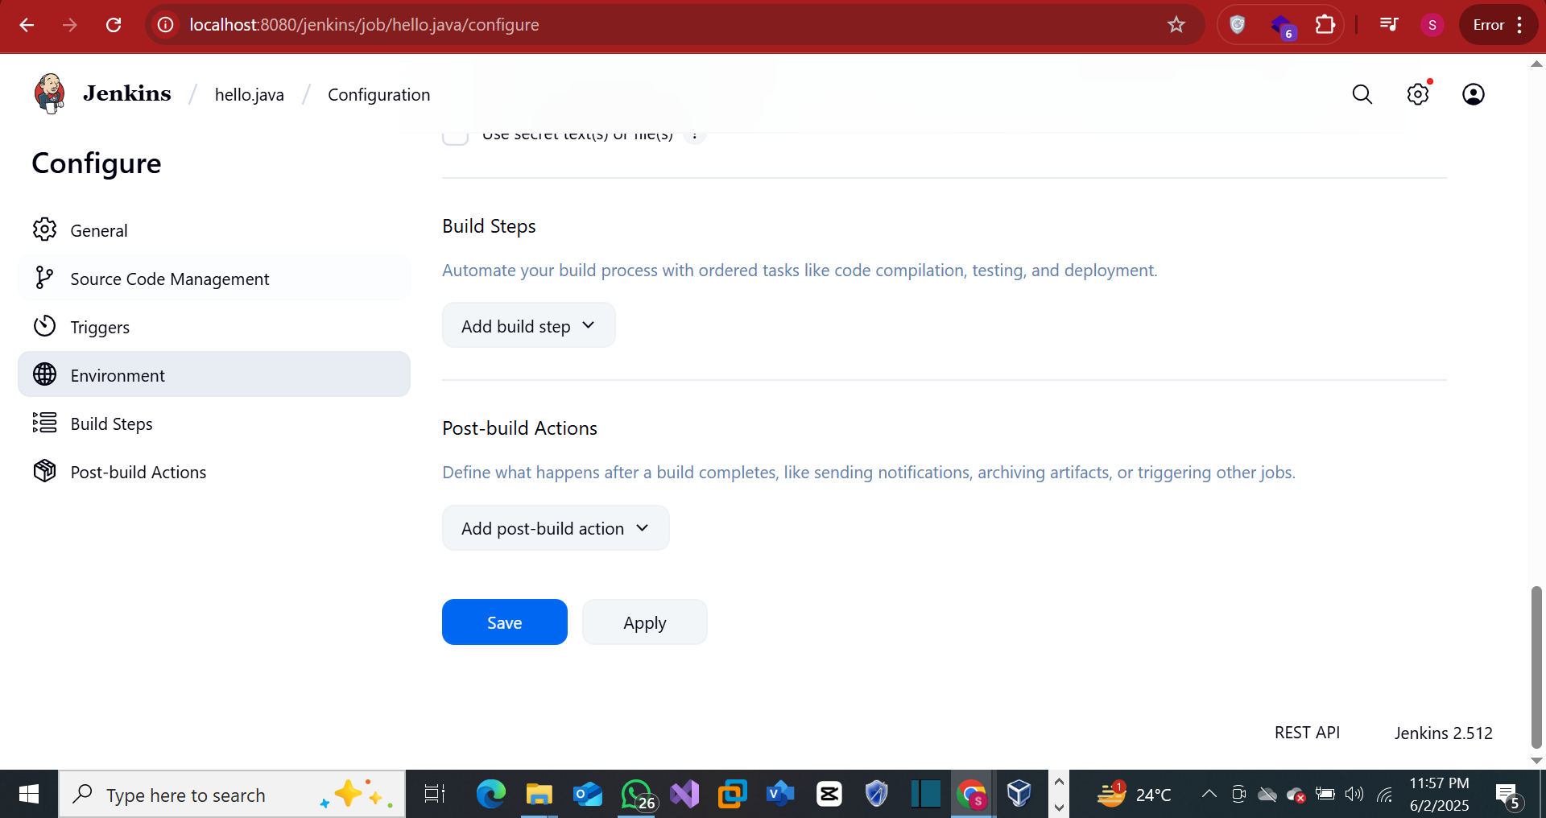

**Step 6 − In the command window, enter the following commands**

**and then click on the Save button.**

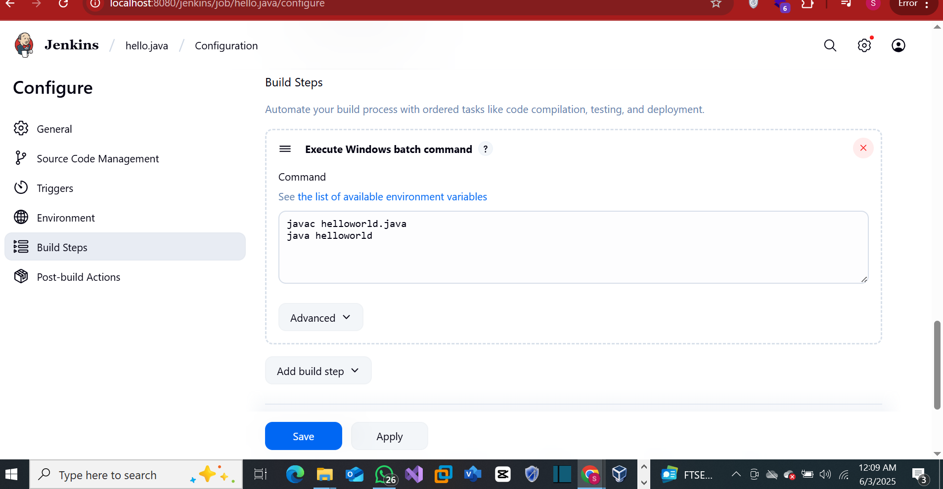

**Step 7 − Once saved, you can click on the Build Now option to see**

**if you have successfully defined the job.**



